|  |  |  |  |  |  |
| --- | --- | --- | --- | --- | --- |
| Date | 23-Nov-22 | | | Tester Name | Richard Belanger |
| Environment | Penfax - Test | | | Login used | TEST2 |
| Operating System | Windows | Version: | Update: | | |
| Software Used | Edge | Version: | Update: | | |
| Not Applicable | Version: | Update: | | |
| Release version | 22.4.1 | | | | |
| Title | M2.07 End a marital status VIA divorce | | | | |
| Test Type | Regression | | | | |
| Test Scenario | In PENFAX end a marital status VIA divorce | | | | |
|  |  | | | | |
| Expected Results | The marital status will be ended. It will then be the marital status of record | | | | |
| Pass/Fail | Pass | | | JIRA# | N/A |

Describe your steps with screenshots:

SID = 106943; Member is Married

PENFAX

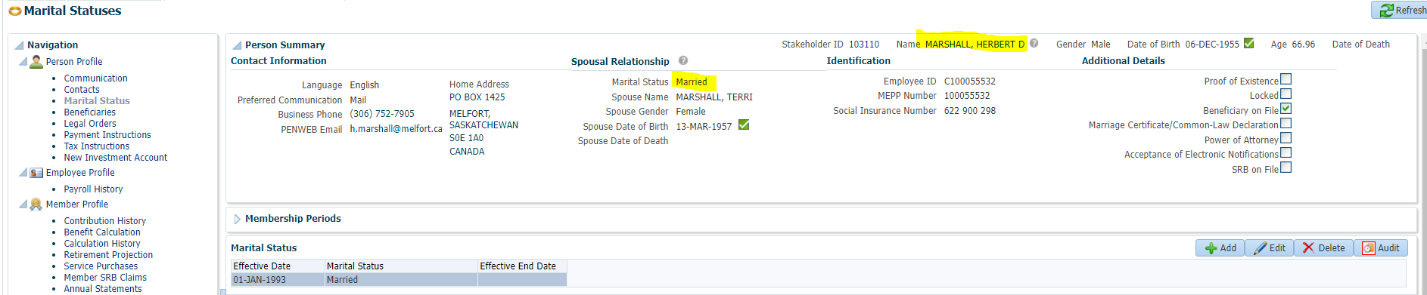

PENWEB

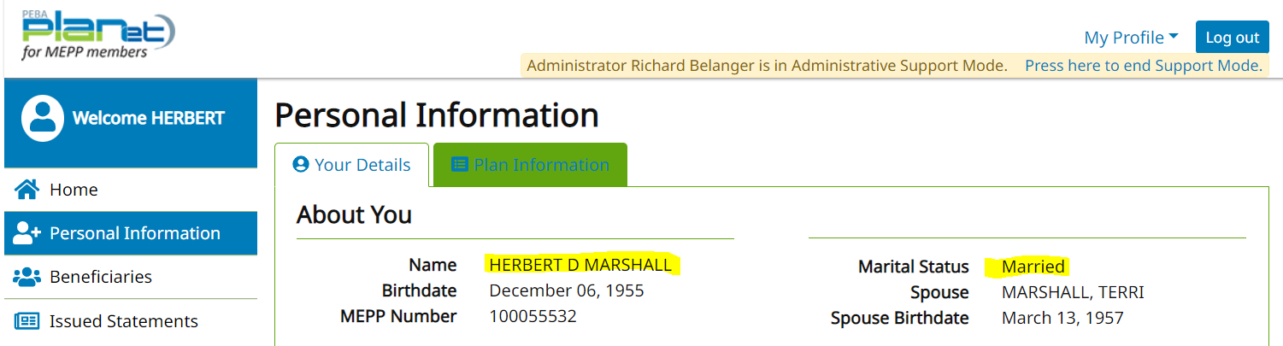

Member is now Divorced

PENFAX

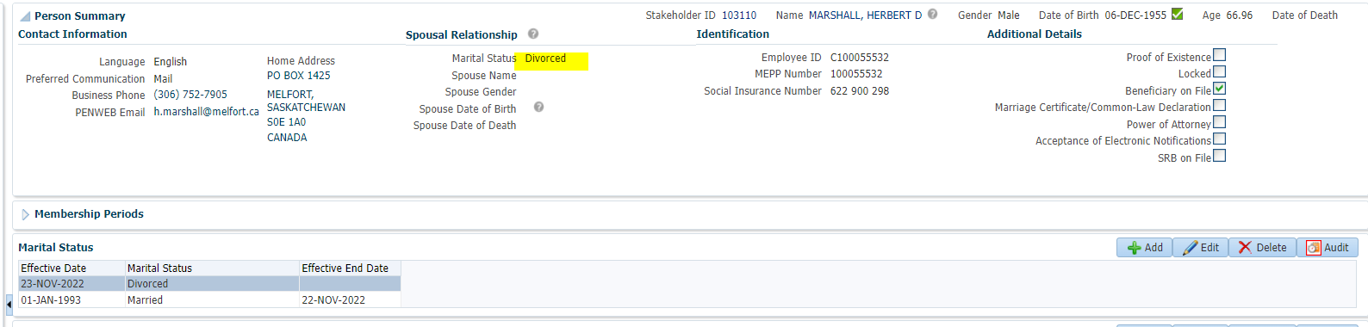

PENWEB

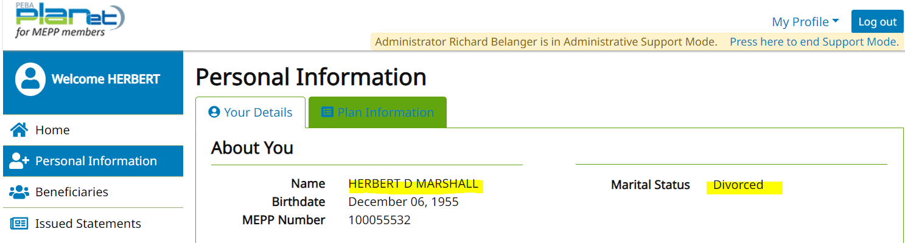

SID = 103960; Member is Married

PENFAX

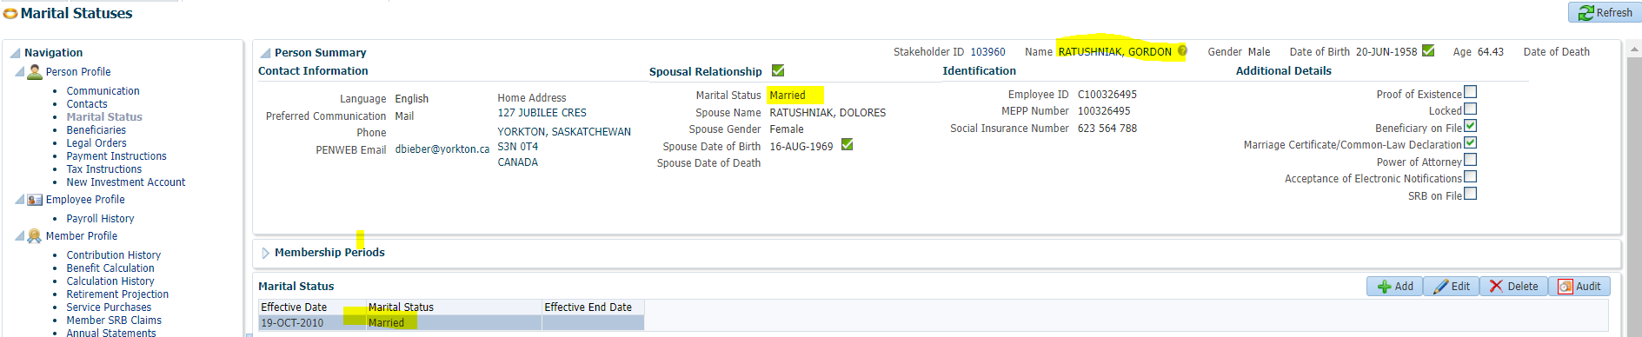

PENWEB

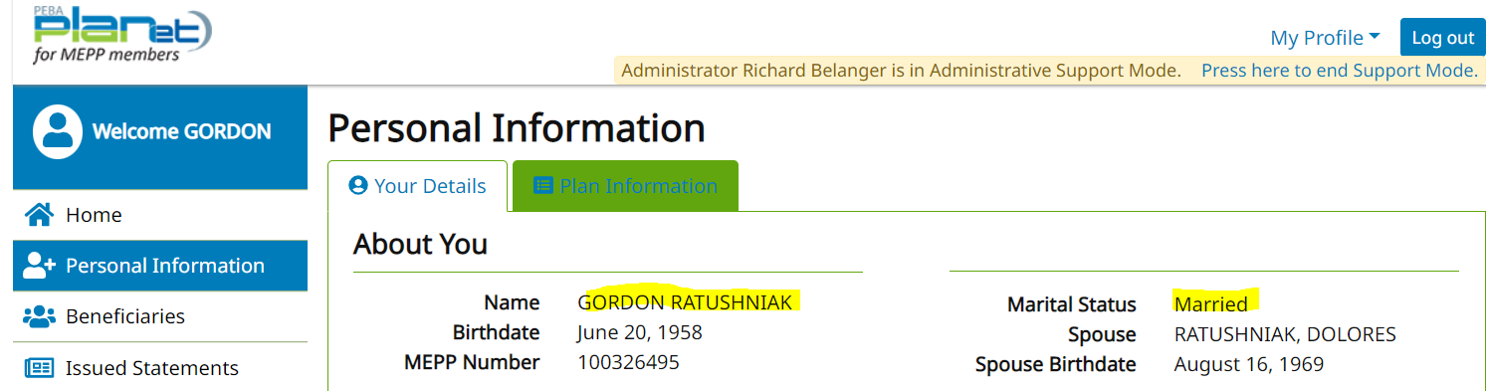

Member is now Divorced

PENFAX

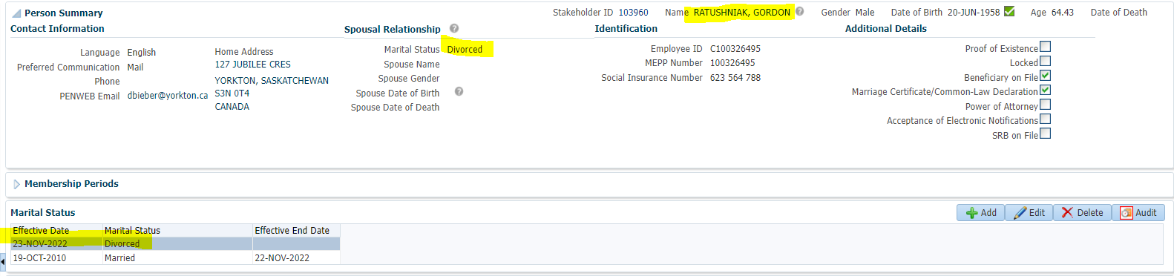

PENWEB

